**South Ayrshire Council**

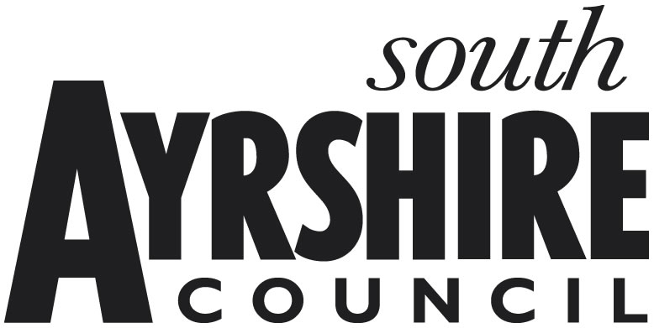

**Partly Unoccupied Property**

This form needs to be completed and returned as soon as possible, either by post to: South Ayrshire Council, Non-Domestic Rates, PO Box 31, Wellington Square, Ayr, KA7 2PL, or by e-mail to: [business.rates@south-ayrshire.gov.uk](mailto:business.rates@south-ayrshire.gov.uk). (a scanned copy is acceptable)

**RELIEF OF RATES FOR LANDS & HERITAGES PARTLY UNOCCUPIED FOR A SHORT TIME**

The following conditions must apply before relief can be granted:

1. that relief only be granted to those subjects which are, or were previously used as an industrial property;
2. that all claims be for a period in excess of 1 month but not more than 3 months;
3. that only one claim be accepted in respect of a subject or part thereof, in each financial year;
4. that such claims only be afforded where the rateable value of the part of the premises in question is equal to or greater than 5% of the total rateable value of the property as per the Valuation Roll or £1,500 whichever was the lesser;
5. that all applications for relief be submitted immediately that part of the property became unoccupied to which the application relates and no relief be granted in respect of any period prior to the day of application;
6. that where relief was claimed, all applications be supported by a plan showing the area of areas involved.

**The declaration at paragraph 9 must be signed and dated**.

Please complete the following questions:

1. **Ratepayer Name:**

2. **Rates Reference:**

3. **Property Address:**

4. **Period of Claim: From (Exact Date):**

**To (Exact Date):**

**YES / NO**

5. **Is this an industrial type property?**

6. **Reason for the applicable part of the**

**property not being occupied:**

7. **It may be necessary to inspect the property; therefore the following information is required:**

* **Contact name:**
* **Contact address:**

* **Contact tel. number:** **Contact e-mail address:**

1. **All claims must be accompanied by a Plan showing the area or areas in respect of which relief is being sought. This will be passed on to the Ayrshire Valuation Joint Board in order that a value is attributed to the unoccupied area for relief purposes.**
2. **I/We understand that the information supplied is to the best of my knowledge and belief accurate, and that I/We understand that to deliberately provide false information for monetary advantage is a criminal offence.**

**Name (Block capitals):**

**Position in Business:**

**Signature:** **Date:**

**E-mail address:**

##### FOR OFFICIAL USE ONLY

Date returned: ……………………. Date processed: …………………….

Relief Period: ……………....to……….............. Industrial or Exempt Category:…………………

Action by: ……………………. Authorised by: …………………….