**South Ayrshire Council**

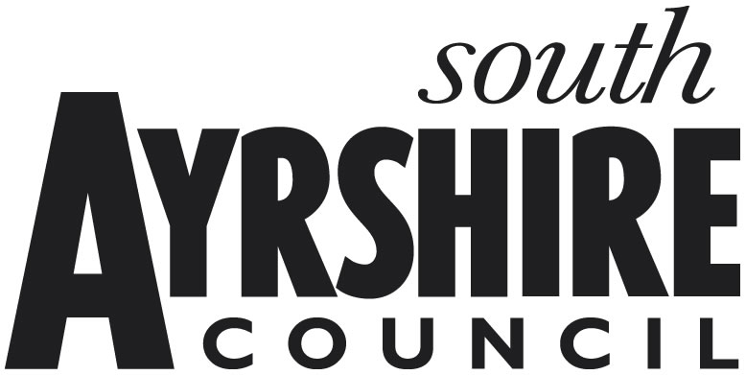

**New & Improved Properties Relief**

The New Entry or New Build Properties relief is available only for properties that have been entered on the Valuation Roll on or after1 April 2018. This will not apply where one or more buildings, or parts of a building, forming part of the new entry were shown in any entry on the Roll on the day immediately prior to the day the new entry takes effect.

The Improved Properties relief is for existing properties that have had their rateable value increased on or after 1 April 2018 as a result of improvements, such as refurbishment or expansion to, or the erection of one or more buildings to, or by the change of use of, the existing lands and heritages. However, this excludes increases caused by the combination, division or reorganisation of lands and heritages shown in a different entry in the Roll on the day before the change takes effect.

This form needs to be completed and returned as soon as possible, either by post to: South Ayrshire Council, Non-Domestic Rates, PO Box 31, Wellington Square, Ayr, KA7 2PL, or by e-mail to: [business.rates@south-ayrshire.gov.uk](mailto:business.rates@south-ayrshire.gov.uk). (a scanned copy is acceptable)

**The declaration at paragraph 7 must be signed and dated**.

Please complete the following questions:

1. **Ratepayer Name:**

2. **Rates Reference:**

3. **Property Address:**

**YES / NO**

4. **Is the property currently occupied?**

Please complete either section 5 or 6 only, unless the property was a new entry on or after 1 April 2018 that has been subsequently improved, in which case both reliefs may apply.

5. **New Entry or New Build Properties**

Date the property was entered on to the Valuation Roll:

**YES / NO**

Has the property been occupied since the date entered on to the Roll?

If **YES**, please give dates of any occupied periods(s):

If **NO**, please give dates of any empty period(s):

6. **Improved Properties**

New Rateable Value:

Previous Rateable Value:

Date the Rateable Value was increased from:

7. **I/We understand that the information supplied is to the best of my knowledge and belief accurate, and that I/We understand that to deliberately provide false information for monetary advantage is a criminal offence.**

**Name (Block capitals):**

**Position in Business:**

**E-mail address:**

**Telephone number:**

**Signature:** **Date:**

##### FOR OFFICIAL USE ONLY

Date returned: ……………………. Date processed: …………………….

Date referred to AVJB: …………………….

Relief Period: ……………....to……….............. Relief Type ……………………

Action by: ……………………. Authorised by: …………………….